Expense Management System

Handle company expense data

Overview of company expense report

Features Draft:

Login (Admin/Employee)

Authentications

Profiles

Expense Table

+Add Expense Filter

|  |  |  |  |  |  |  |  |  |
| --- | --- | --- | --- | --- | --- | --- | --- | --- |
| ID | Description | Amount | Date | Category | Reference | Action | Notes |  |
| 1 |  |  |  |  |  | Update/Delete |  |  |
| 2 |  |  |  |  |  |  |  |  |

* Sortable table
* Show Total
* Print

Filter

* Search
* Date (time range, specific date, date range)
* Amount (top 5, min 5)

Expense Category (Ex: Food, Salary, Components)

* Provider / Reference
* Payment method (optional)
* Receipt

Expense Report

* Expense View
* Expense Calendar
* Expense Analysis

Dashboard

Expense Report Graphical/Chart View

Optional:

* Manage users
* Project Cost
* Estimated Budget
* Expense Policy

Resources

<https://github.com/EGavilan-Media/Expense-Management-System> (php)

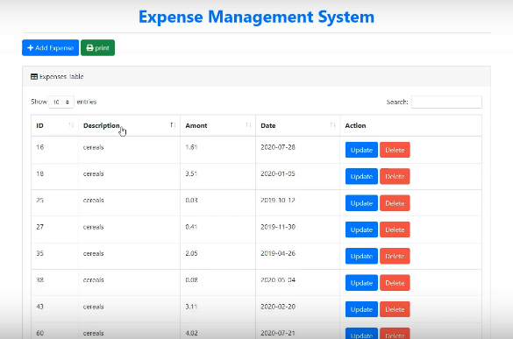

**<https://egavilanmedia.com/income-and-expenses-management-system-2/>

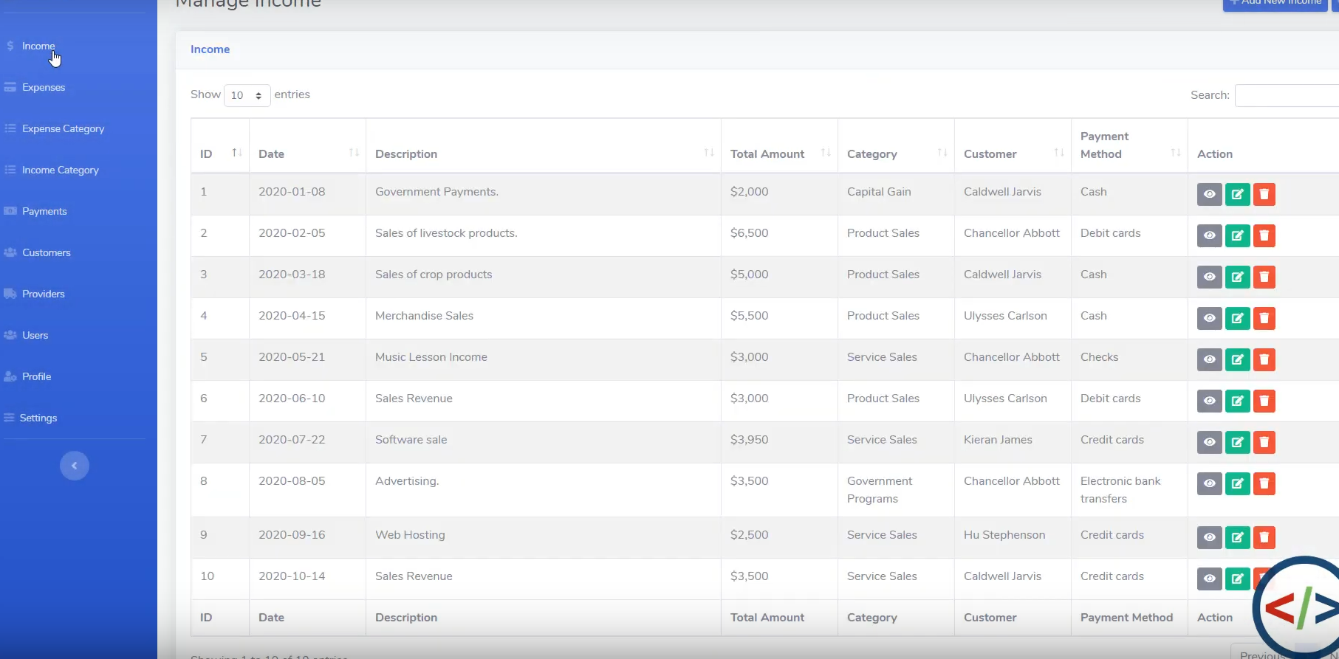

<http://freeproject24.com/daily-income-and-expense-management-system-in-php-with-source-code/(php)>

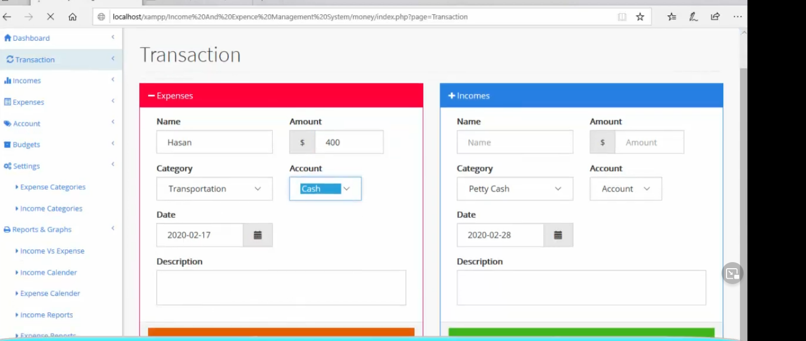

<https://www.youtube.com/watch?v=dOsRdDB0QnU> (zoho expense)

<https://scholarworks.calstate.edu/downloads/fn106z027> (full report)(ASP.net)

Cost Management

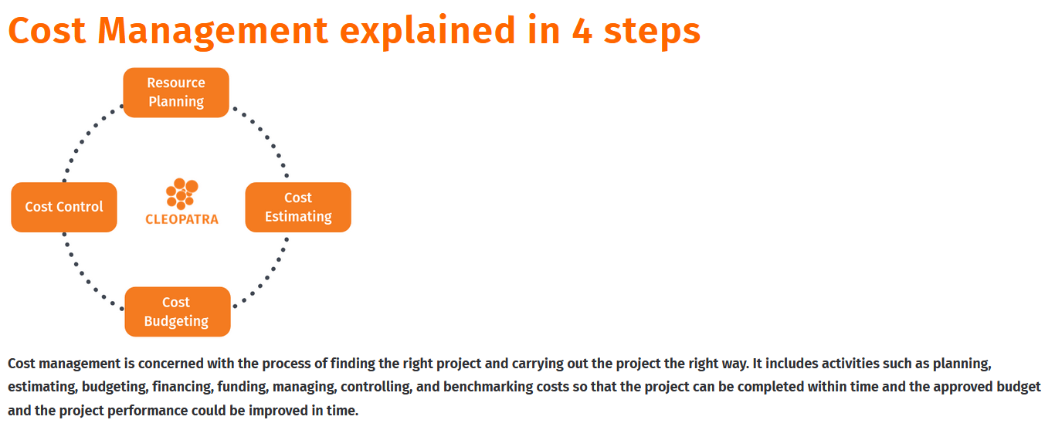

<https://www.aresprism.com/products/cost-management-software/>

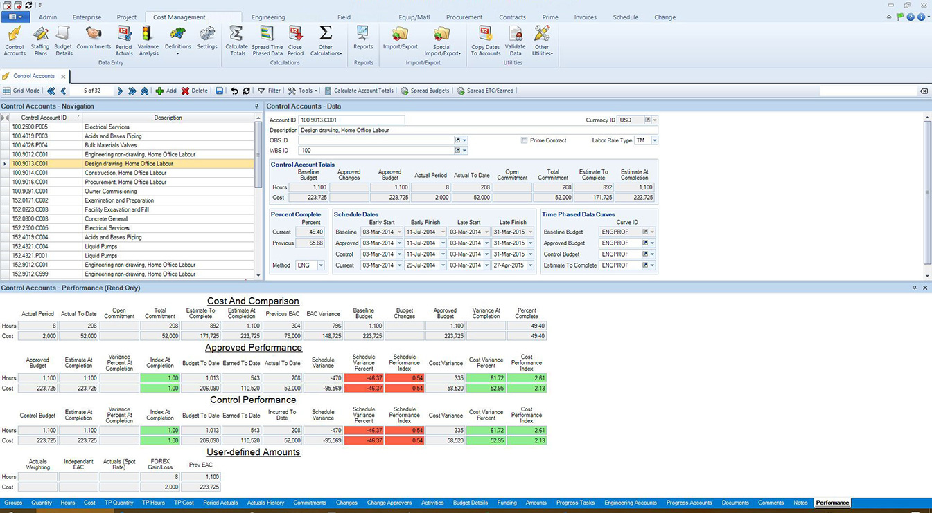

Features:

* Create unlimited control accounts to manage project data at the level of detail desired by the user
* Establish time-phased budgets to represent cash flow plans for projects
* Use enterprise reporting periods for enterprise cash flow analysis
* Measure performance and productivity using cost, hour, and quantity control elements
* Implement [change management](https://www.aresprism.com/change-management-software/) processes to maintain control of scope and cost
* Create and manage workflows. Plan & forecast resources by reporting period

<https://www.bitrix24.com/uses/free-project-cost-management-software.php>